“Strategies and Tools for Divergent Thinking”
Some basic principles
There are four general guidelines for supporting divergent thinking:
- Deferring judgment (this includes both criticism and praise)
- Encouraging the numbers—collecting every possible idea
- Supporting the strange—striving for the unusual and encouraging different perspectives
- Looking for combinations of ideas that might work together; i.e., building off the ideas of others
Environment and roles
Divergent thinking is more likely to thrive in an environment that allows for different types of expression, encourages risk, and allows failure. As trainers, we can support divergent thinking by facilitating and supporting individual expression.
For example, we can:
- Provide support and encouragement when ideas are blocked
- Encourage autonomy and ownership
- Help learners appreciate how they learn, supporting metacognitive processes
We also play a role as community leaders, nurturing group environments so that many different voices are heard and respected (see also Social Learning and Radical Innovation).
Divergent thinking techniques
There are many different techniques that encourage divergent thinking. Although I’ll discuss these techniques as opportunities for social learning and collaboration, these also can be used as solo activities.
Brainstorming
This is probably the technique we are most familiar with. During brainstorming, participants spontaneously contribute ideas in response to a problem statement. Crafting a good problem statement requires some skill. You don’t want the problem to be so broad that it will be difficult to find patterns in ideas and possible solutions. You also don’t want it to be so specific that the solutions seem relatively inevitable.
You’ll also want to consider the size and mix of people in your brainstorming group. Keep the number of individuals in a brainstorming group fairly small (e.g., 5-12 people) so that no one feels lost in the crowd. Additionally, gather group members who will naturally have different perspectives, e.g., researchers, product development people, sales people/customer-facing people, business development people, and yes, even, your patent attorneys.
If you’re facilitating a brainstorming session:
- Remind group members of the guidelines (e.g., defer judgment, generate as many ideas as possible, look for the wild, disruptive ideas, consider the creative combination of ideas)
- Help all voices to be heard
- Have a transcriber in the room to capture all the ideas (or use a recorder or videotape the session), since you’ll have your hands full as a facilitator
There are many techniques you can explore to make brainstorming more interesting. SCAMPER is one of them.
- Substitute: What are the alternatives to materials, processes, methods you’re already using/doing?
- Combine: How can you combine seemingly disparate ideas?
- Adapt: How can you adapt something you’re already doing/using for a project?
- Modify: What materials, processes, methods can you modify to solve a problem?
- Put to other use: Can you put a material, process, method to another use?
- Eliminate: What can you do to eliminate problems and inefficiencies? What materials, methods, and steps, can be eliminated?
- Rearrange: How can you move around materials, method steps, and processes, to solve a problem?
More brainstorming games and exercises are described here. Exploratree provides some additional tools and templates for supporting metacognitive processes.
Brainwriting
Here, groups of people who are brainstorming don’t have to speak to each other, at least initially. Ideas are written down (e.g., on sticky notes or index cards) and shared later. This encourages all voices to be heard and prevents people from forgetting their ideas as they wait for an opportunity to speak. Building on ideas occurs after ideas are shared. In a variation of this technique, one participant writes down three ideas on a piece of paper in response to a problem statement and passes it on to the next participant who writes down three different ideas and then passes it on to the next participant who continues the process.
Six Thinking Hats® system
Pioneered by Edward de Bono, the Six Thinking® Hats system encourages parallel thinking— viewing a problem from different perspectives depending on which “hat” you’re wearing (de Bono, 1985), as illustrated below.
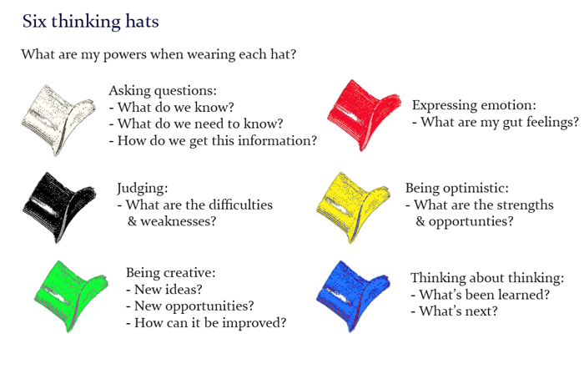
Lateral thinking
The crux of lateral thinking is to attempt to solve problems by unorthodox or apparently illogical methods. In his book, Serious Creativity (1992), de Bono describes some lateral thinking techniques for spurring creativity.
Concept fans: Representing a problem as a central circle, write down possible solutions as a series of lines radiating outward from the circle. If the solutions aren’t quite what you want, try reframing the idea. Draw it as a second circle connected to the first circle and write down possible solutions for the new problem. Keep repeating the process, reframing problem statements and fanning out ideas.
Provocations: Start with a provocative statement, for example, “We should abolish all formal training.” Then examine:
- The consequences of the statement
- Potential benefits
- The circumstances in which the statement describes a good solution
- The supports needed to make the idea work
- The practical implications of the idea on a day-to-day, moment-to-moment basis
Then change the parameters of the idea, e.g., “We should make formal training less than 5% of our training efforts,” and begin the process again, repeating until you reach results that are optimal for your organization.
Random input: Choose a random object (e.g., a noun from a dictionary or an object in your office or another environment) and associate it with a problem you’re thinking about. What are the connections? How can these connections be used to solve or expand upon the problem? As an example, if the problem is how to optimize informal learning in the workplace, some objects you might consider are playgrounds, campsites, crockpots, scavenger hunts, etc. Your challenge is then to consider what attributes of these objects could be used to solve the problem.
Challenge ideas: This involves asking why something is done the way it’s currently done. You can challenge problems, solutions, or anything in between. The idea is that when you challenge something, you start thinking of alternatives.
Disproving: Take the crowdsourced view of things and challenge it. See if you can support your own different position.
Tools and tech to complement divergent thinking
Technology offers some exciting ways to complement and enhance divergent thinking techniques. With the advent of collaborative web-based technologies, groups can be geographically dispersed and ideas can be collected in real-time (or a close approximation), asynchronously, or by using some combination of these approaches.
Some collaboration tools include:
- Wallwisher – a collaborative bulletin board
- edistorm – a collaborative whiteboard you can post sticky notes on
- Scribblar – a collaborative whiteboard
- Mindmapping tools – great for concept fanning and the building-upon stages of brainstorming
And don’t forget that you can use social networking platforms like Miio and Twitter for some basic brainstorming. Use hashtags on Twitter for public brainstorming. Miio allows you more room to add text, multimedia, and threaded conversations, and an important plus, provides the option to create private groups.
Of course, this is just the tip of the iceberg, and for some larger collections of tools and tech, you’re invited to check out:
- 50+ tools for web-based collaboration
- The Top 100 Tools for Learning (for a list organized according to categories, see also, The Tools Directory and check out the collaboration tools)
- Cooltoolsforschools collaboration tools
- Go2Web20 – collaboration tools
- Web 2.0’s Top 1000 List – the mega-list of Web 2.0 tools, see particularly: Chat 2.0, Collaboration 2.0, Communication 2.0, and Community 2.0

Works Cited
Rees, Dianne. “Strategies and Tools for Divergent Thinking.” Instructional Design Fusions.
23 October 2010. n.p. Web. 13 March 2015.

